**Java Polymorphism**

In this tutorial, we will learn about Java polymorphism and its implementation with the help of examples.

Polymorphism is an important concept of object-oriented programming. It simply means more than one form.

That is, the same entity (method or operator or object) can perform different operations in different scenarios.

**Example: Java Polymorphism**

class Polygon {

// method to render a shape

public void render() {

System.out.println("Rendering Polygon...");

}

}

class Square extends Polygon {

// renders Square

public void render() {

System.out.println("Rendering Square...");

}

}

class Circle extends Polygon {

// renders circle

public void render() {

System.out.println("Rendering Circle...");

}

}

class Main {

public static void main(String[] args) {

// create an object of Square

Square s1 = new Square();

s1.render();

// create an object of Circle

Circle c1 = new Circle();

c1.render();

}

}

[Run Code](https://www.programiz.com/java-programming/online-compiler)

**Output**

Rendering Square...

Rendering Circle...

In the above example, we have created a superclass: Polygon and two subclasses: Square and Circle. Notice the use of the render() method.

The main purpose of the render() method is to render the shape. However, the process of rendering a square is different than the process of rendering a circle.

Hence, the render() method behaves differently in different classes. Or, we can say render() is polymorphic.

**Why Polymorphism?**

Polymorphism allows us to create consistent code. In the previous example, we can also create different methods: renderSquare() and renderCircle() to render Square and Circle, respectively.

This will work perfectly. However, for every shape, we need to create different methods. It will make our code inconsistent.

To solve this, polymorphism in Java allows us to create a single method render() that will behave differently for different shapes.

**Note**: The print() method is also an example of polymorphism. It is used to print values of different types like char, int, string, etc.

We can achieve polymorphism in Java using the following ways:

1. [Method Overriding](https://www.programiz.com/java-programming/method-overriding)
2. [Method Overloading](https://www.programiz.com/java-programming/method-overloading)
3. Operator Overloading

**Java Method Overriding**

During [inheritance in Java](https://www.programiz.com/java-programming/inheritance), if the same method is present in both the superclass and the subclass. Then, the method in the subclass overrides the same method in the superclass. This is called method overriding.

In this case, the same method will perform one operation in the superclass and another operation in the subclass. For example,

**Example 1: Polymorphism using method overriding**

class Language {

public void displayInfo() {

System.out.println("Common English Language");

}

}

class Java extends Language {

@Override

public void displayInfo() {

System.out.println("Java Programming Language");

}

}

class Main {

public static void main(String[] args) {

// create an object of Java class

Java j1 = new Java();

j1.displayInfo();

// create an object of Language class

Language l1 = new Language();

l1.displayInfo();

}

}

[Run Code](https://www.programiz.com/java-programming/online-compiler)

**Output**:

Java Programming Language

Common English Language

In the above example, we have created a superclass named Language and a subclass named Java. Here, the method displayInfo() is present in both Language and Java.

The use of displayInfo() is to print the information. However, it is printing different information in Language and Java.

Based on the object used to call the method, the corresponding information is printed.

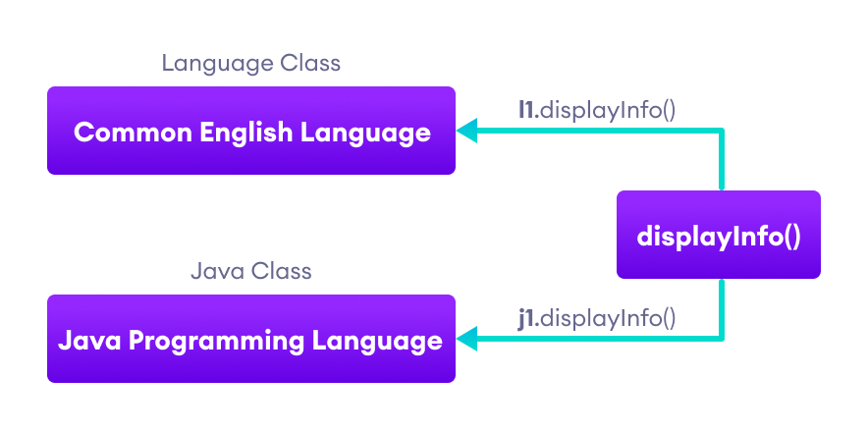Working of Java Polymorphism

**Note**: The method that is called is determined during the execution of the program. Hence, method overriding is a **run-time polymorphism**.

**2. Java Method Overloading**

In a Java class, we can create methods with the same name if they differ in parameters. For example,

void func() { ... }

void func(int a) { ... }

float func(double a) { ... }

float func(int a, float b) { ... }

This is known as method overloading in Java. Here, the same method will perform different operations based on the parameter.

**Example 3: Polymorphism using method overloading**

class Pattern {

// method without parameter

public void display() {

for (int i = 0; i < 10; i++) {

System.out.print("*");

}

}

// method with single parameter

public void display(char symbol) {

for (int i = 0; i < 10; i++) {

System.out.print(symbol);

}

}

}

class Main {

public static void main(String[] args) {

Pattern d1 = new Pattern();

// call method without any argument

d1.display();

System.out.println("\n");

// call method with a single argument

d1.display('#');

}

}

[Run Code](https://www.programiz.com/java-programming/online-compiler)

**Output**:

**********

##########

In the above example, we have created a class named Pattern. The class contains a method named display() that is overloaded.

// method with no arguments

display() {...}

// method with a single char type argument

display(char symbol) {...}

Here, the main function of display() is to print the pattern. However, based on the arguments passed, the method is performing different operations:

* prints a pattern of *, if no argument is passed or
* prints pattern of the parameter, if a single char type argument is passed.

**Note**: The method that is called is determined by the compiler. Hence, it is also known as compile-time polymorphism.

**3. Java Operator Overloading**

Some operators in Java behave differently with different operands. For example,

* + operator is overloaded to perform numeric addition as well as string concatenation, and
* operators like &, |, and ! are overloaded for logical and bitwise operations.

Let's see how we can achieve polymorphism using operator overloading.

The + operator is used to add two entities. However, in Java, the + operator performs two operations.

1. When + is used with numbers (integers and floating-point numbers), it performs mathematical addition. For example,

int a = 5;

int b = 6;

// + with numbers

int sum = a + b; // Output = 11

2. When we use the + operator with strings, it will perform string concatenation (join two strings). For example,

String first = "Java ";

String second = "Programming";

// + with strings

name = first + second; // Output = Java Programming

Here, we can see that the + operator is overloaded in Java to perform two operations: **addition** and **concatenation**.

**Note**: In languages like C++, we can define operators to work differently for different operands. However, Java doesn't support user-defined operator overloading.

**Polymorphic Variables**

A variable is called polymorphic if it refers to different values under different conditions.

Object variables (instance variables) represent the behavior of polymorphic variables in Java. It is because object variables of a class can refer to objects of its class as well as objects of its subclasses.

**Example: Polymorphic Variables**

class ProgrammingLanguage {

public void display() {

System.out.println("I am Programming Language.");

}

}

class Java extends ProgrammingLanguage {

@Override

public void display() {

System.out.println("I am Object-Oriented Programming Language.");

}

}

class Main {

public static void main(String[] args) {

// declare an object variable

ProgrammingLanguage pl;

// create object of ProgrammingLanguage

pl = new ProgrammingLanguage();

pl.display();

// create object of Java class

pl = new Java();

pl.display();

}

}

[Run Code](https://www.programiz.com/java-programming/online-compiler)

**Output**:

I am Programming Language.

I am Object-Oriented Programming Language.

In the above example, we have created an object variable pl of the ProgrammingLanguage class. Here, pl is a polymorphic variable. This is because,

* In statement pl = new ProgrammingLanguage(), pl refer to the object of the ProgrammingLanguage class.
* And, in statement pl = new Java(), pl refer to the object of the Java class.